1. Bubble sorting code implementation in c language

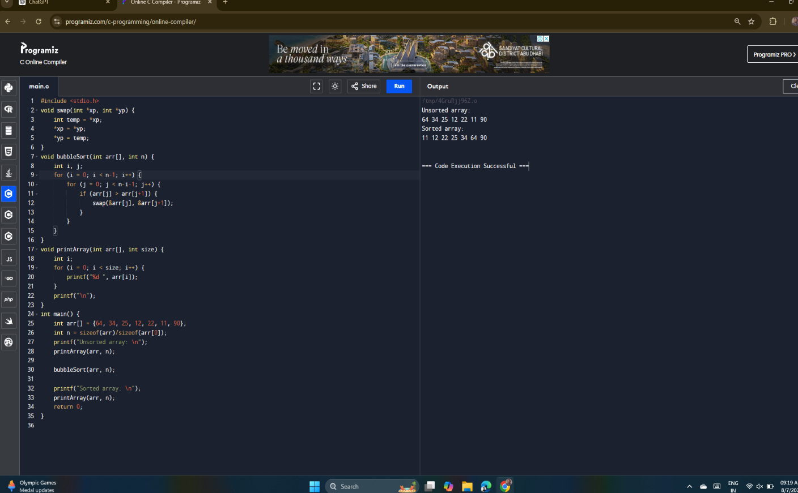

2.Selection Sort code implementation in c language